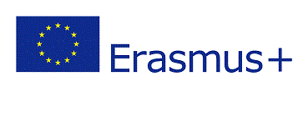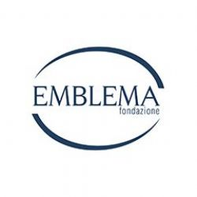

***ERASMUS+ KA1 – VET***

***E.M.B.L.E.M. – “European Mobility Boosting Learners from Emilia Romagna”***

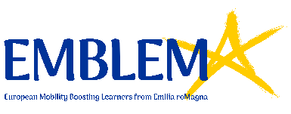

***IL PROGETTO n° 2019-1-IT01-KA102-007045***

***Codice CUP: G35F19000940006***

***Bologna, 30/07/2020***

**ELENCO AMMESSI AI COLLOQUI DI SELEZIONE IN DATA 30/07/2020**

|  |
| --- |
| MILAGROS LUCIA BASAS |
|  |